**Cuizine:**

Kheer

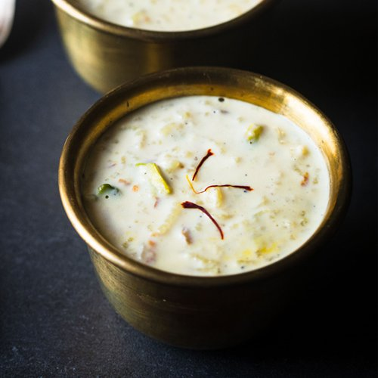

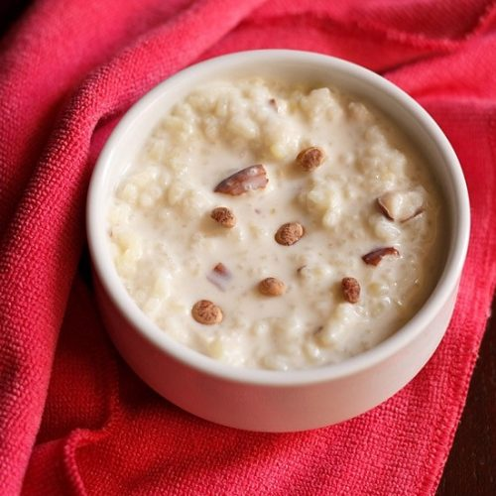

**Kheer** is a rice pudding, originating from the Indian subcontinent, made by boiling with milk and sugar one of the following: rice, broken wheat, tapioca, vermicelli, sweet corn, etc. It is flavoured with cardamom, raisins, saffron, cashews, pistachios, almonds or other dry fruits and nuts. It is typically served during a meal or as a dessert. It is also known in some regions as **meetha bhaat**, **payasam**, **payasa**, and **phirni.** Kheer is prepared in festivals, temples, and all special occasions. The term *kheer* (used in North India) may derive from the Sanskrit word *Ksheera* (which means "milk").